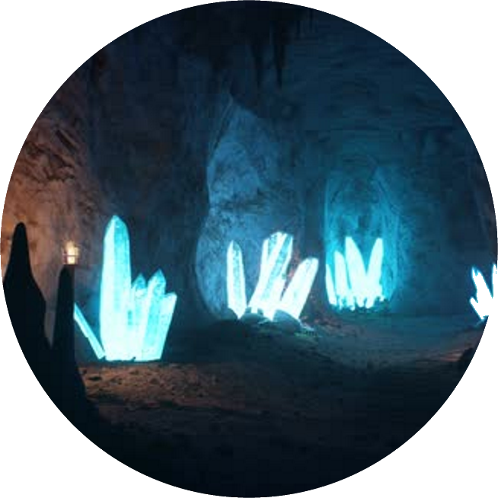

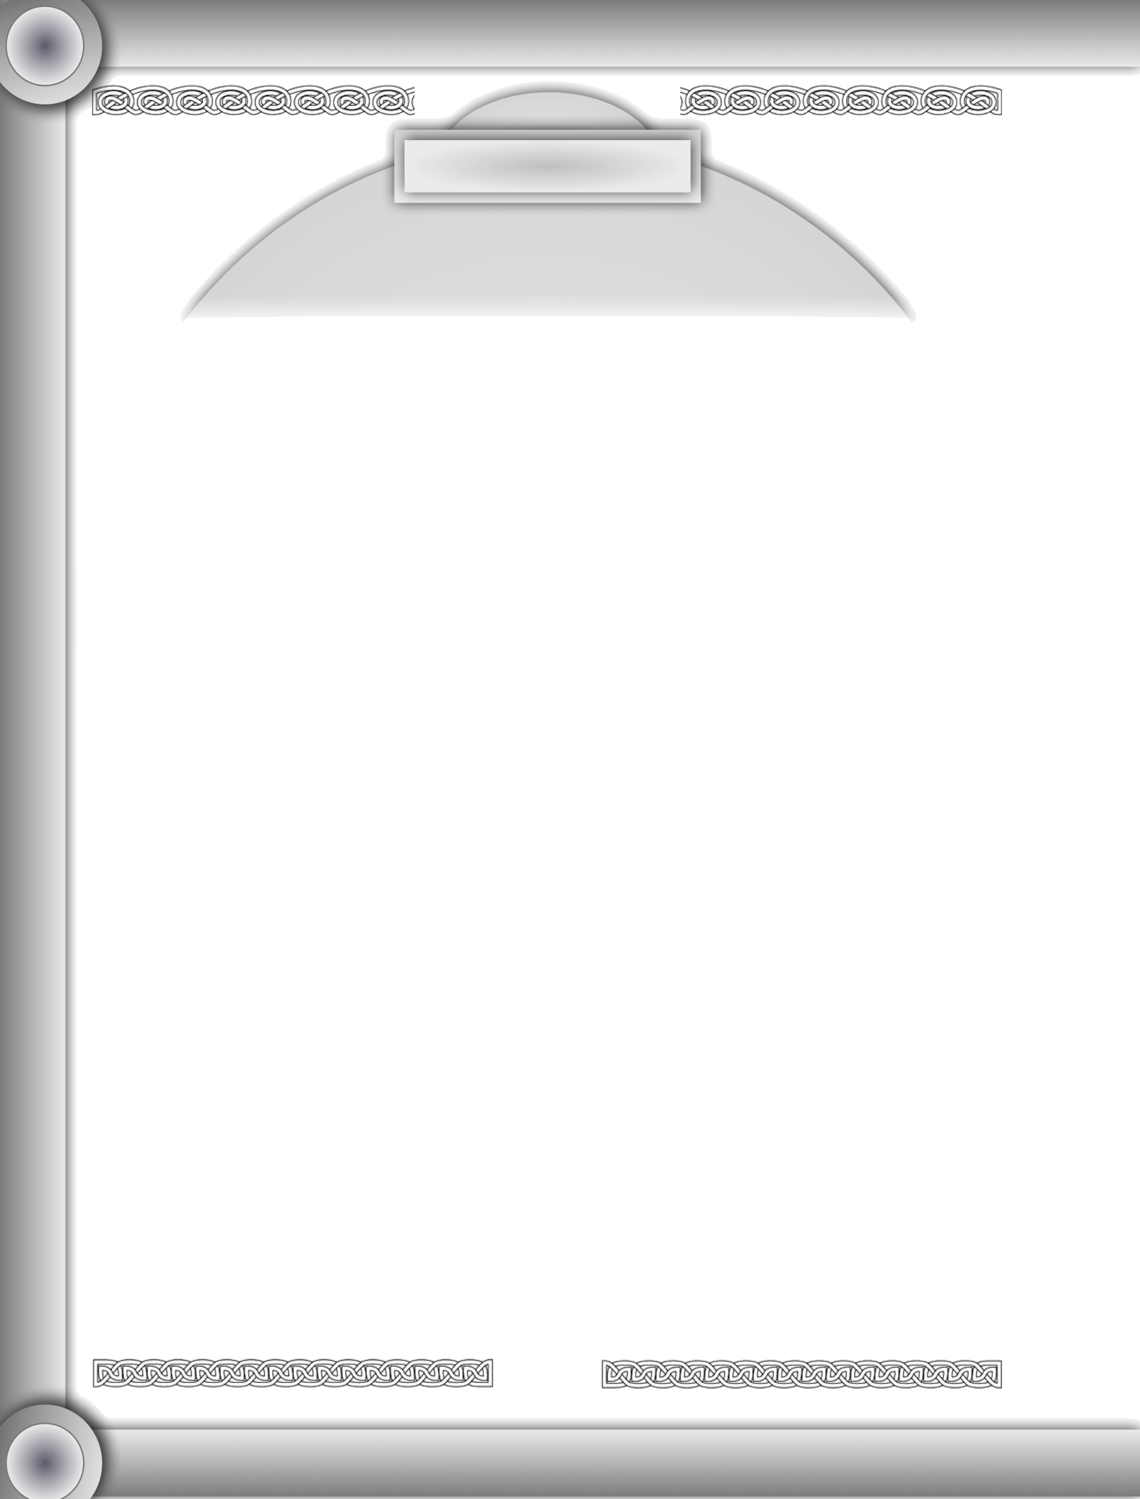

Vis Sources Generator

**Concept**: Lance Additon

**Author:** Lance Additon

**Illustrations**: Lance Additon

All texts and illustrations belong to their respective authors.

*Vis Sources Generator* is totally free of charge.

# Credits

*Vis Sources Generator* is an independent

publication dedicated to all *Ars Magicka* players.

*Vis Sources Generator* is not affiliated with Atlas Games or White Wolf Gaming Studio. References to trademarks of those companies are not intended to infringe upon the rights of those parties.

Consequently, *Vis Sources Generator* is in no way an official product.

2

Ars Magica rpg was created by  
Jonathan Tweet and Mark  
Rhein•Hagen.

Table design and contents inspired by the awesome book that I cannot recommend enough, *Tome of Adventure Design* by Matthew J. Finch (www.talesofthefroggod.com)

When trying to determine the details of an item, location, etc and I am stumped I use *Mythic Variations II's* detail check.



Vis Sources Generator

# Table of Contents

Credits 2

Table of Contents 3

Introduction 5

Tables 6



Vis Sources Generator

# Introduction

The vis sources generator was created to aid the Storyguide (whether they are in a group or playing solo) in creating vis sources without having to put too much thought into the process. This generator is especially useful in a solo capacity where one doesn't know the nature of the source until it is actually generated.

3

In order to use this book, you'll also need another great resource mentioned in the credits and that is the *Tome of Adventure* design upon which some of the tables are based upon. Rather than repeat the tables here (not to mention violate copyright laws) I recommend you support the author and buy the book (see credits above).

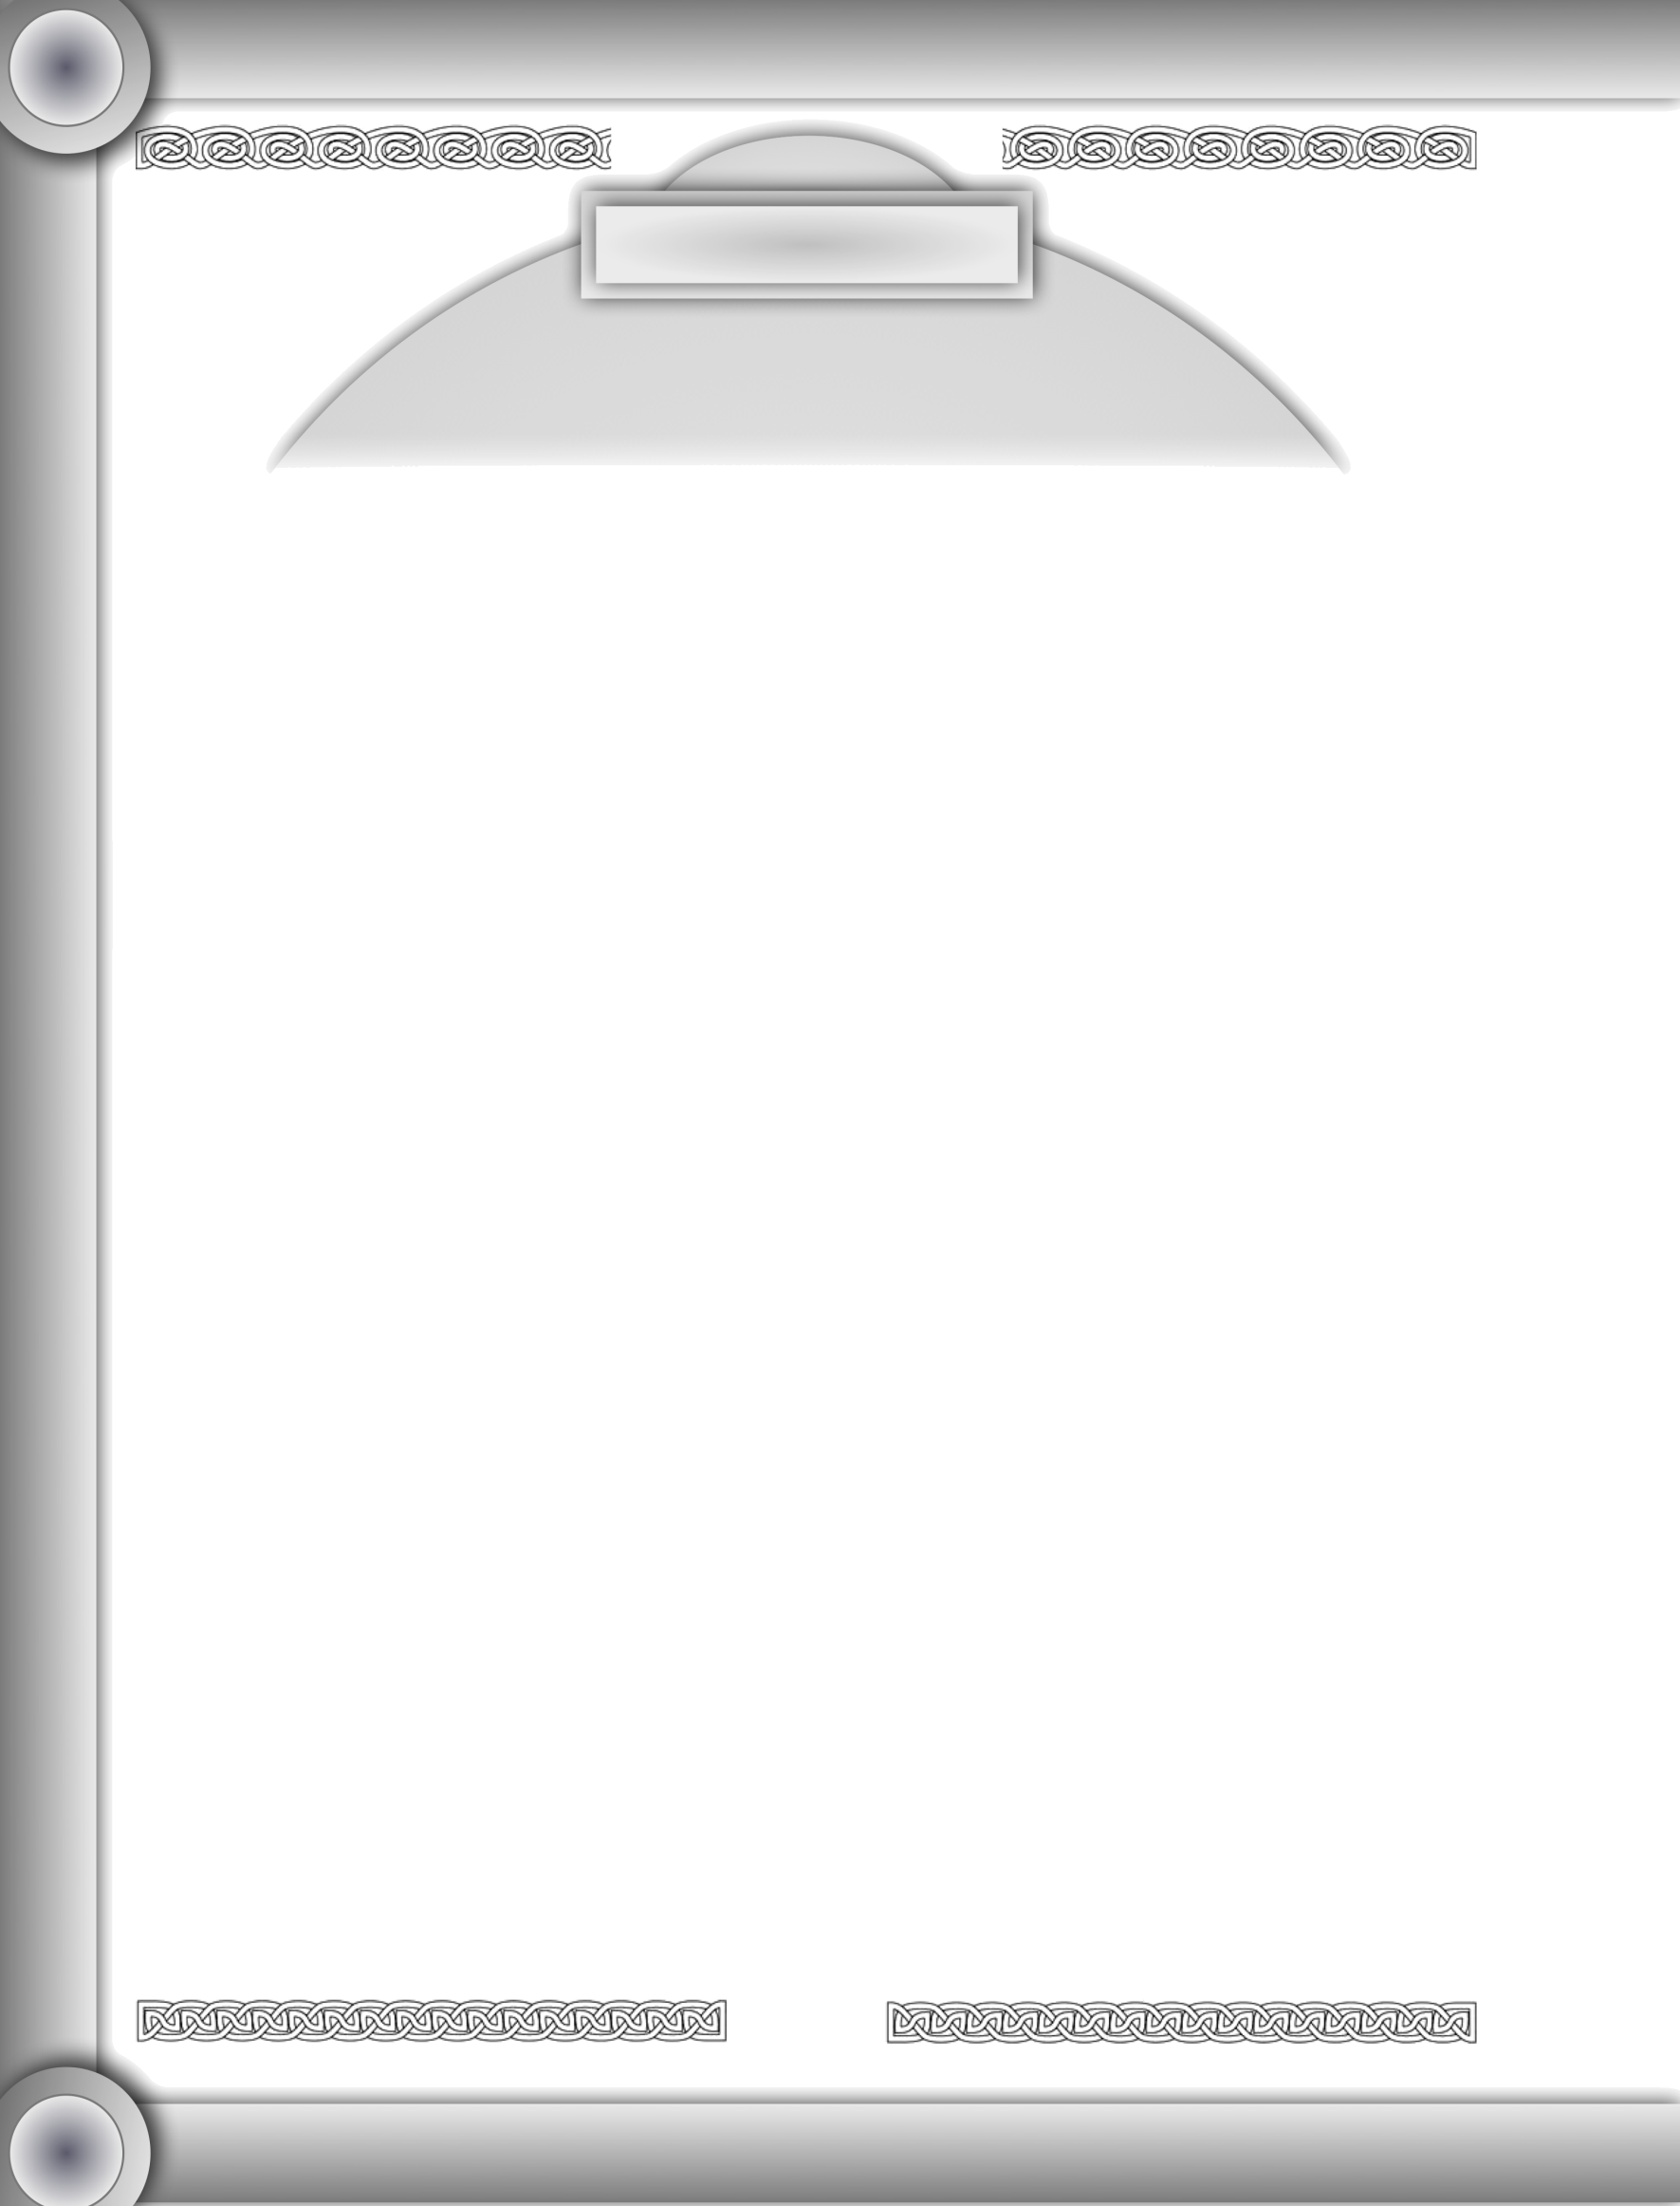

# Tables

Vis Sources Generator

Table 1-1: Vis Source Variability

|  |  |
| --- | --- |
| Die Roll | Variability |
| 1d10 | A d10 is used to determine the number of pawns/year that the Vis source produces. |

Table 2-1: Vis Source Nature

|  |  |
| --- | --- |
| Die Roll | Nature |
| 1-3 | Vis source originates from an organism (see **Book 2 of *Tome of Adventure Design*** for more details) |
| 4-6 | Vis source originates from a location (see **Table 1-1A/B, 4-1& accompanying tables [for type environment of location], of *Tome of Adventure Design*** for more details) |
| 7-9 | Vis source originates from an object (see **Table 1-5, column 'Item Subject of Missions' and Table 3-7 from *Tome of Adventure Design*** for more details) |
| 10 | Roll Again |

Table 3-1: Vis Source Visibility

|  |  |
| --- | --- |
| Die Roll | Visibility |
| 1-3 | Open (*Mythic Variations II*, detail check) to determine the details. |
| 4-6 | Mobile (*Mythic Variations II*, detail check) to determine the nature of the source's mobility |
| 7-9 | Hidden (*Mythic Variations II*, detail check) to determine the details of how the vis source is hidden. |
| 10 | Roll Again |

Table 4-1: Vis Source Occurrence Frequency

|  |  |
| --- | --- |
| Die Roll | Frequency |
| n/a | see **Table 1-29 of *Tome of Adventure Design*** for more details |

Table 5-1: Vis Source Distance

|  |  |
| --- | --- |
| Die Roll | Distance |
| 1-100 | d100 determines how many miles away the vis source is. |

Table 6-1: Vis Source Size

|  |  |
| --- | --- |
| Die Roll | Size |
| 1-25 | Fits in the palm of your hand |
| 26-50 | Can carry in both arms |
| 51-75 | Can carry in cart |
| 76-100 | Can carry on ship |

Table 7-1: Vis Source Texture

|  |  |
| --- | --- |
| Die Roll | Texture |
| 1-4 | Bumpy |
| 5-7 | Clammy |
| 8-10 | Cold |
| 11-13 | Damp |
| 14-16 | Dry |
| 17-19 | Dusty |
| 20-22 | Elastic |
| 23-25 | Etched |
| 26-28 | Flaky |
| 29-31 | Powdery |
| 32-34 | Flexible |
| 35-37 | Foamy |
| 38-40 | Freezing |
| 41-43 | Gelatinous |
| 44-46 | Glassy |
| 47-49 | Gooey |
| 50-52 | Gravelly |
| 53-55 | Gritty |
| 56-58 | Hairy |
| 59-61 | Hot |
| 62-64 | Knotted |
| 65-67 | Metallic |
| 68-70 | Muddy |
| 71-73 | Mushy |
| 74-76 | Padded |
| 77-79 | Prickly |
| 80-82 | Ribbed |
| 83-85 | Rocky |
| 86-88 | Slick |
| 89-91 | Smooth |
| 92-94 | Soggy |
| 95-97 | Sticky |
| 98-100 | Viscous |

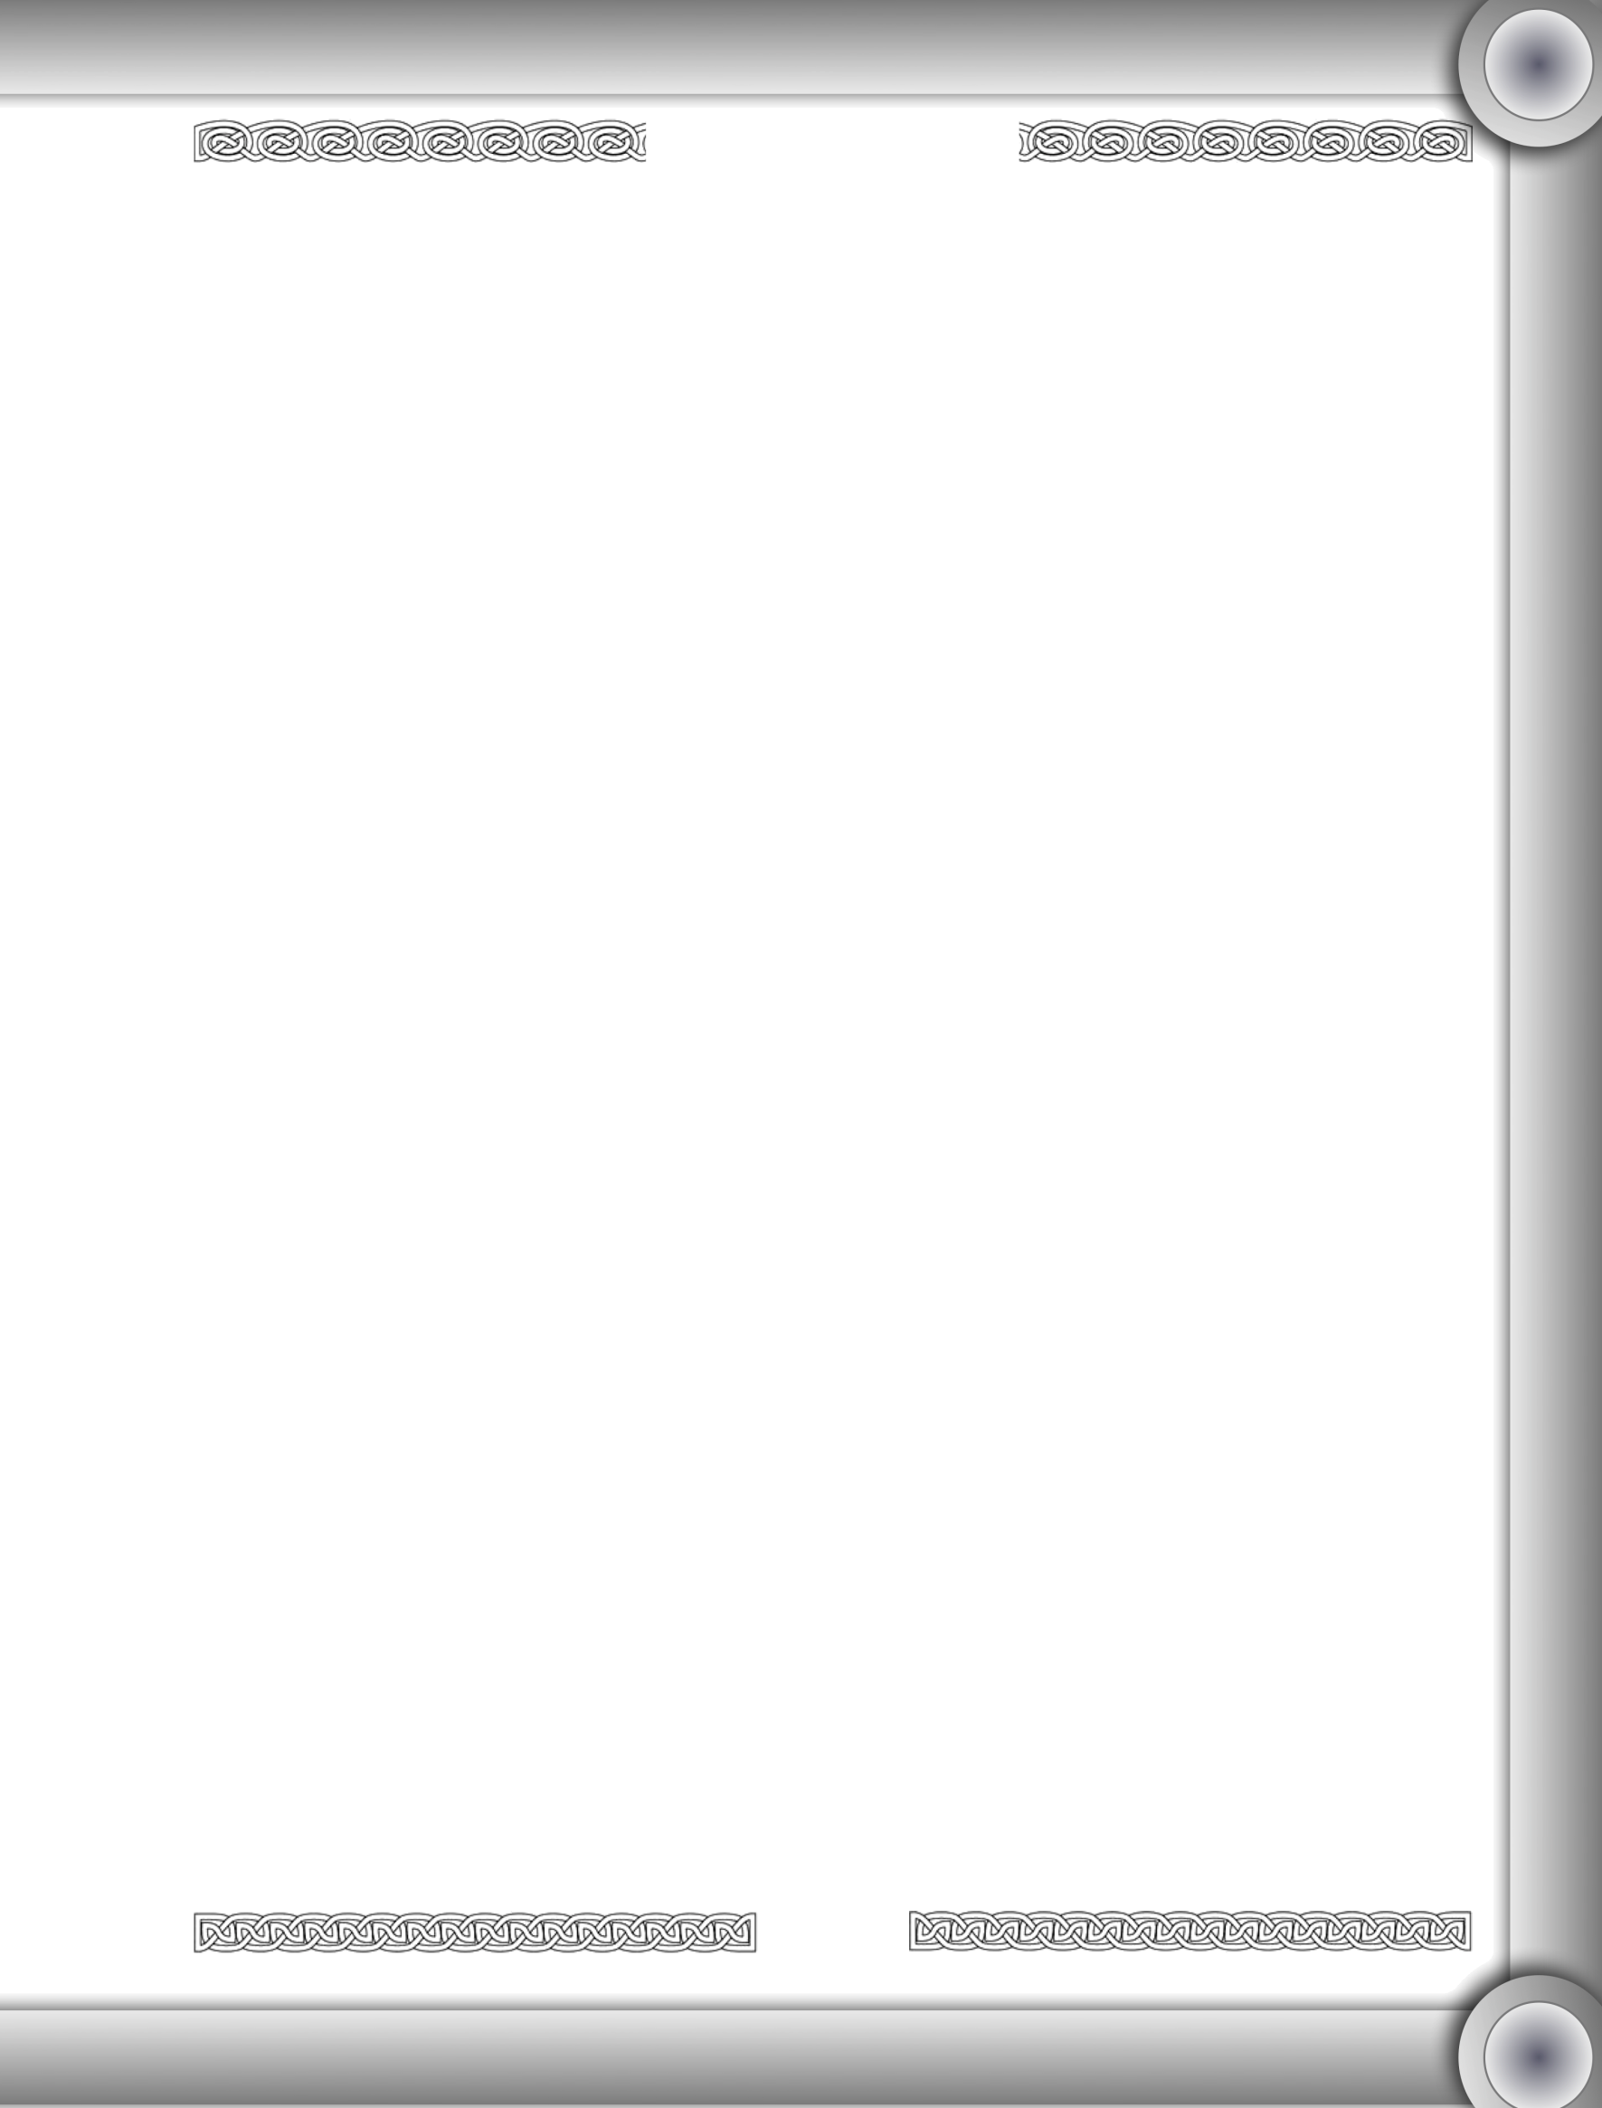

Vis Sources Generator

Table 8-1a: Vis Source Appearance (Color)

|  |  |
| --- | --- |
| Die Roll | Color |
| 1-9 | Black |
| 10-18 | Blue |
| 19-27 | Brown |
| 28-36 | Gold |
| 37-44 | Green |
| 45-52 | Grey |
| 53-60 | Orange |
| 61-68 | Purple |
| 69-76 | Red |
| 77-84 | Silver |
| 85-93 | White |
| 94-00 | Yellow |

Table 8-1b: Vis Source Appearance (Shape)

|  |  |  |  |
| --- | --- | --- | --- |
| Die Roll | Shape | Die  Roll | Quality |
| 1-14 | Conformal* | 1-20 | Asymmetrical |
| 15-28 | Conical | 21-40 | Irregular |
| 29-42 | Cubical | 41-60 | Perfect |
| 43-56 | Flat | 61-80 | Rough |
| 57-70 | Rectangular | 81-00 | Symmetrical |
| 71-85 | Spherical |  |  |
| 86-00 | Oval |  |  |

*Conforms to the shape of the container it is in.

Table 8-1c: Vis Source Appearance (Structural Integrity)

|  |  |
| --- | --- |
| Die Roll | Structural Integrity |
| 1-20 | Flimsy |
| 21-40 | Rigid |
| 41-60 | Bendable |
| 61-80 | Sturdy |
| 81-00 | Weak |

Table 8-1d: Vis Source Appearance (Smell)

|  |  |  |  |  |  |
| --- | --- | --- | --- | --- | --- |
| Die Roll | Smell | Die  Roll | Strength | Die  Roll | Effect |
| 1-5 | Acidic | 1-20 | Faint | 1-20 | Agitating |
| 6-10 | Aromatic | 21-40 | None | 21-40 | Calming |
| 11-15 | Citrusy | 41-60 | Noticeable | 41-60 | Sickening |
| 16-20 | Earthy | 61-80 | Overpowering | 61-80 | None |
| 21-25 | Fishy | 81-00 | Strong | 81-00 | Pleasing |
| 26-30 | Flowery |  |  |  |  |
| 31-35 | Minty |  |  |  |  |
| 36-40 | Moldy |  |  |  |  |
| 41-45 | Musty |  |  |  |  |
| 46-50 | None |  |  |  |  |
| 51-55 | Pine |  |  |  |  |
| 56-60 | Rancid |  |  |  |  |
| 61-65 | Smoky |  |  |  |  |
| 66-70 | Sour |  |  |  |  |
| 71-76 | Spicy |  |  |  |  |
| 77-82 | Stale |  |  |  |  |
| 83-88 | Stinky |  |  |  |  |
| 89-94 | Sweet |  |  |  |  |
| 95-00 | Woody |  |  |  |  |

Table 9-1a: Vis Source Harvesting Time Limit/Catalyst

|  |  |
| --- | --- |
| Die Roll | Time Limit |
| 1-11 | None |
| 12-22 | Days |
| 23-33 | Hours |
| 34-44 | Minutes |
| 45-55 | Months |
| 56-66 | Seconds |
| 67-77 | Individual Performs An Action |
| 78-88 | Special event - Natural Event |
| 89-00 | Special event - Magical Event |

Table 9-1b: Vis Source Harvesting (Natural Event)

|  |  |
| --- | --- |
| Die Roll | Natural Event |
| 1-12 | Weather Event |
| 13-24 | Solar Event |
| 25-36 | Lunar Event |
| 37-48 | Calendar Event |
| 49-61 | Creature Event |
| 62-74 | Sound Event |
| 75-87 | Light Event |
| 88-00 | Smell Event |

Table 9-1c: Vis Source Harvesting (Magical Event)

|  |  |
| --- | --- |
| Die Roll | Magical Event |
| 1-25 | Until a spell expires or is cast |
| 26-50 | Until a ritual expires or is cast |
| 51-75 | Until a magical aura/effect is removed or placed |
| 76-00 | Until a magical item is removed or placed |